SERVICE PACKAGE
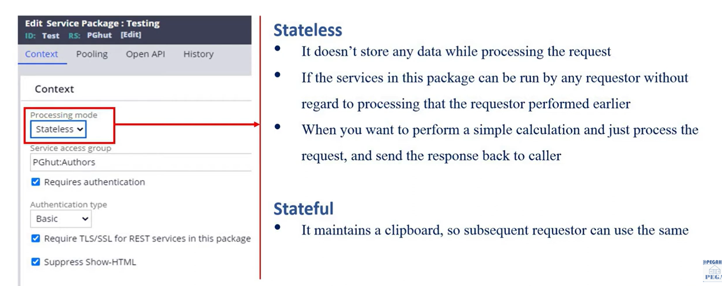

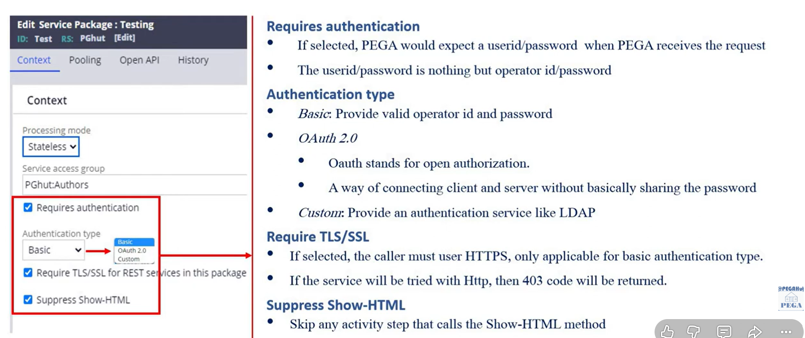

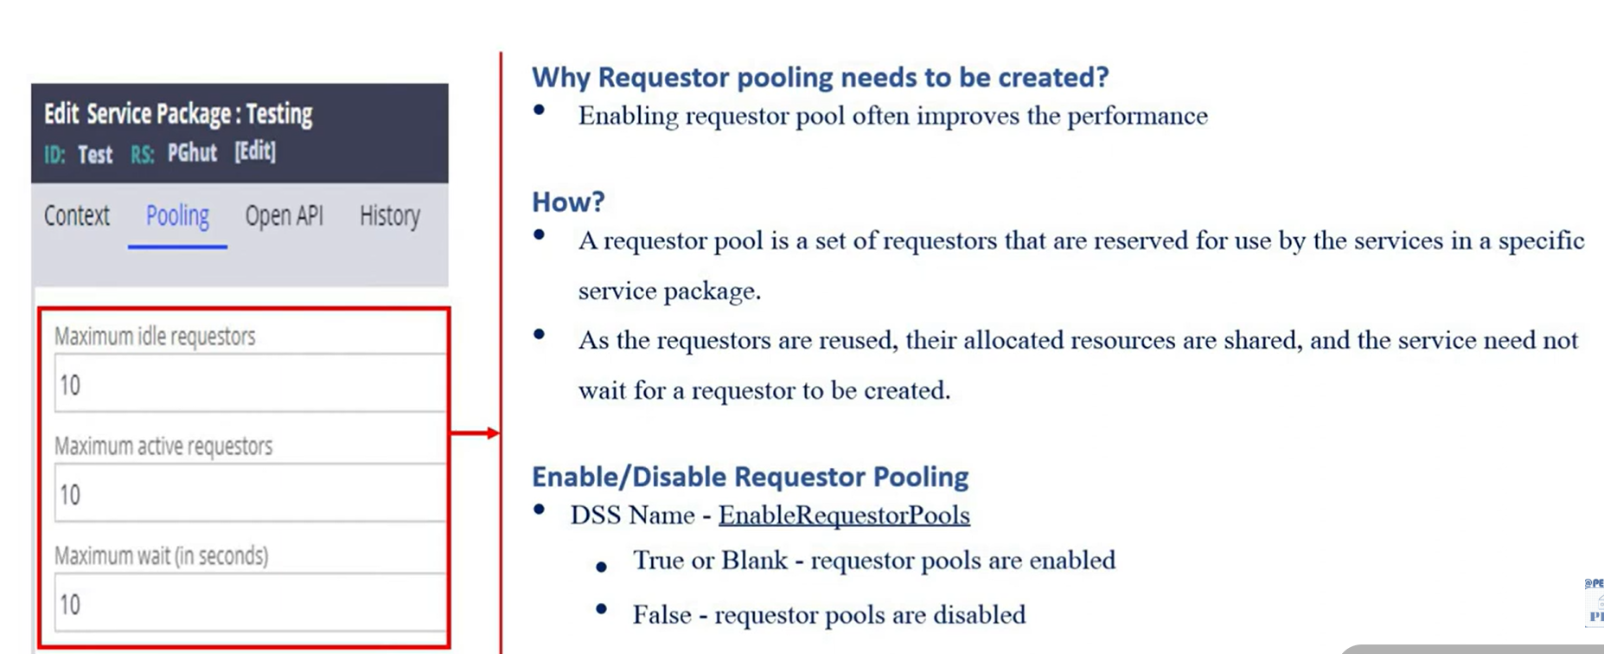
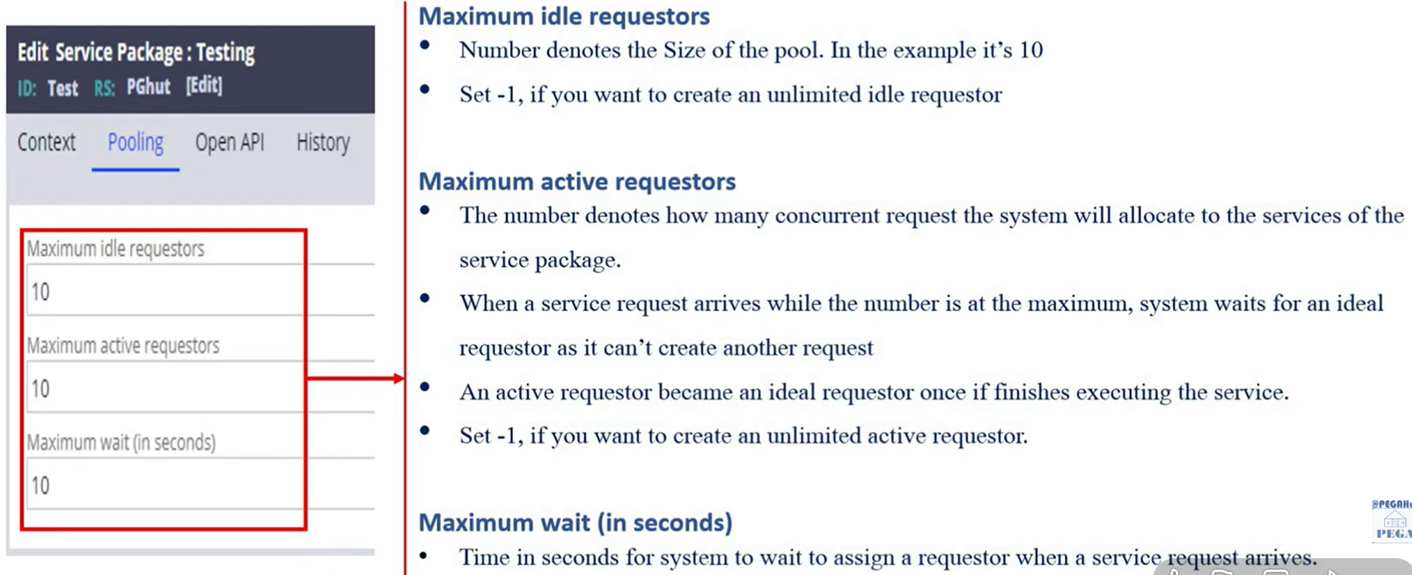

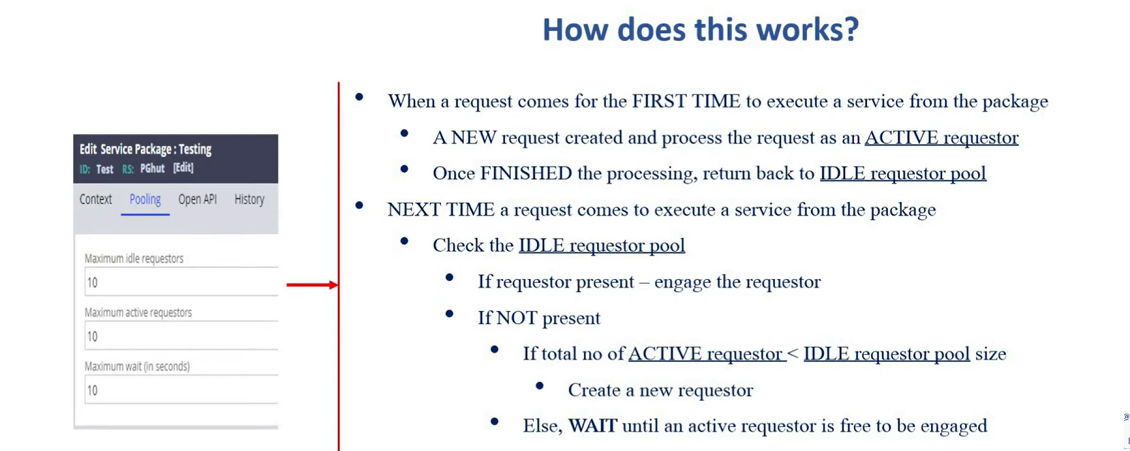

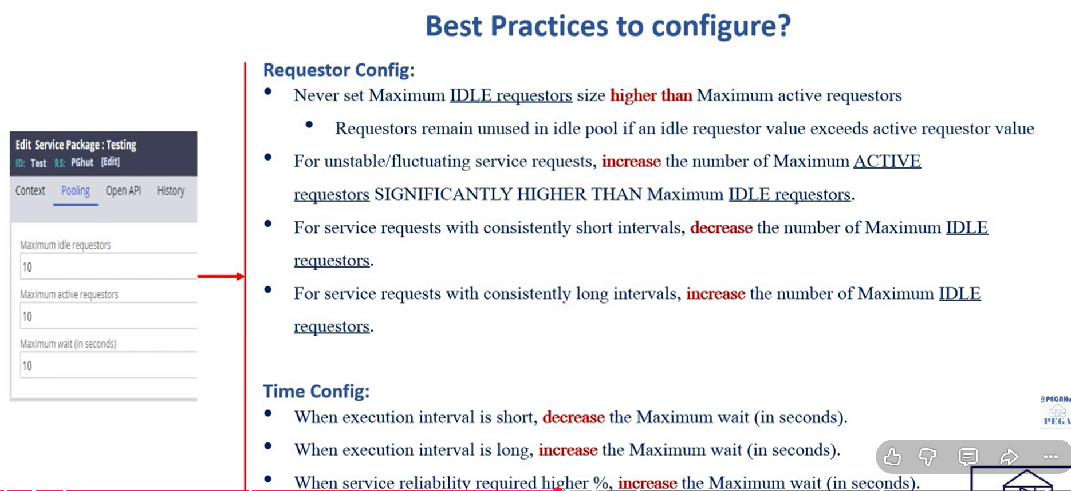

SERVICE REST:
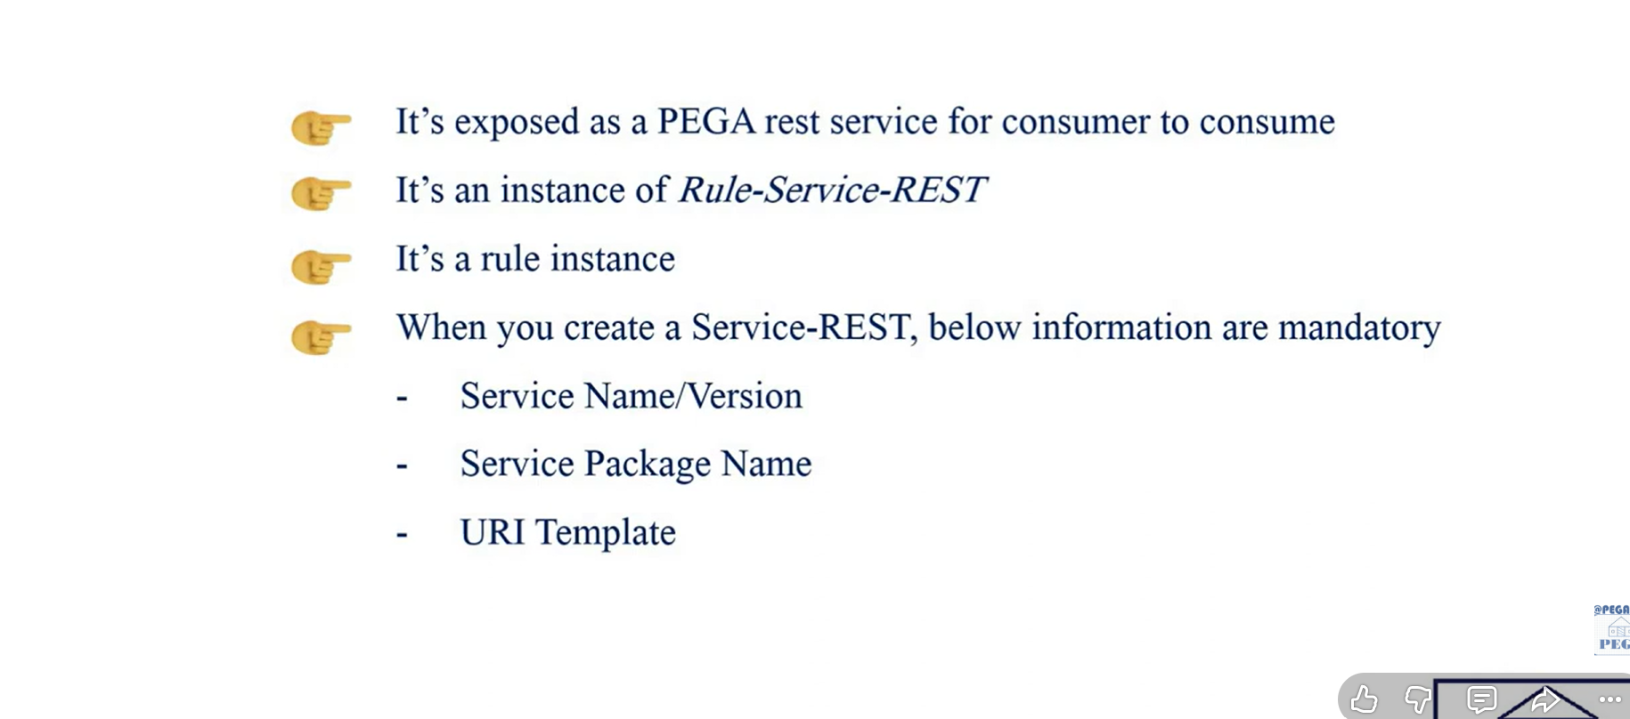

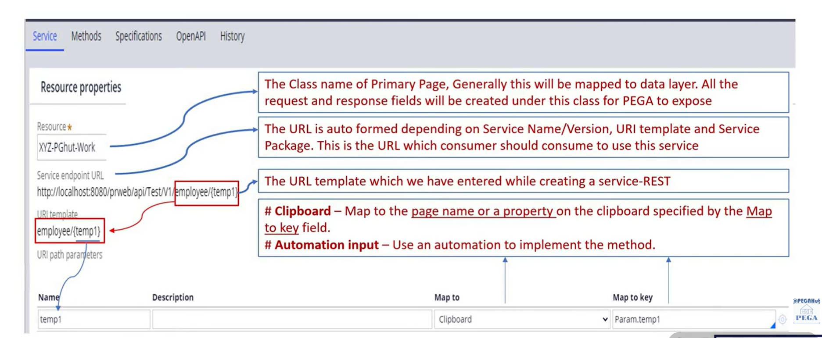

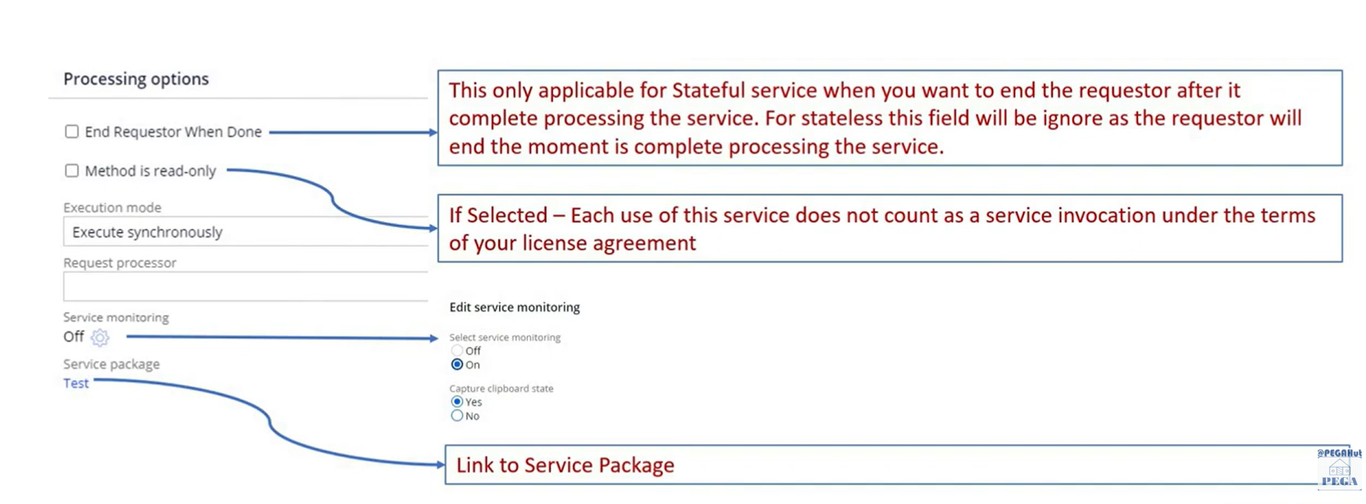

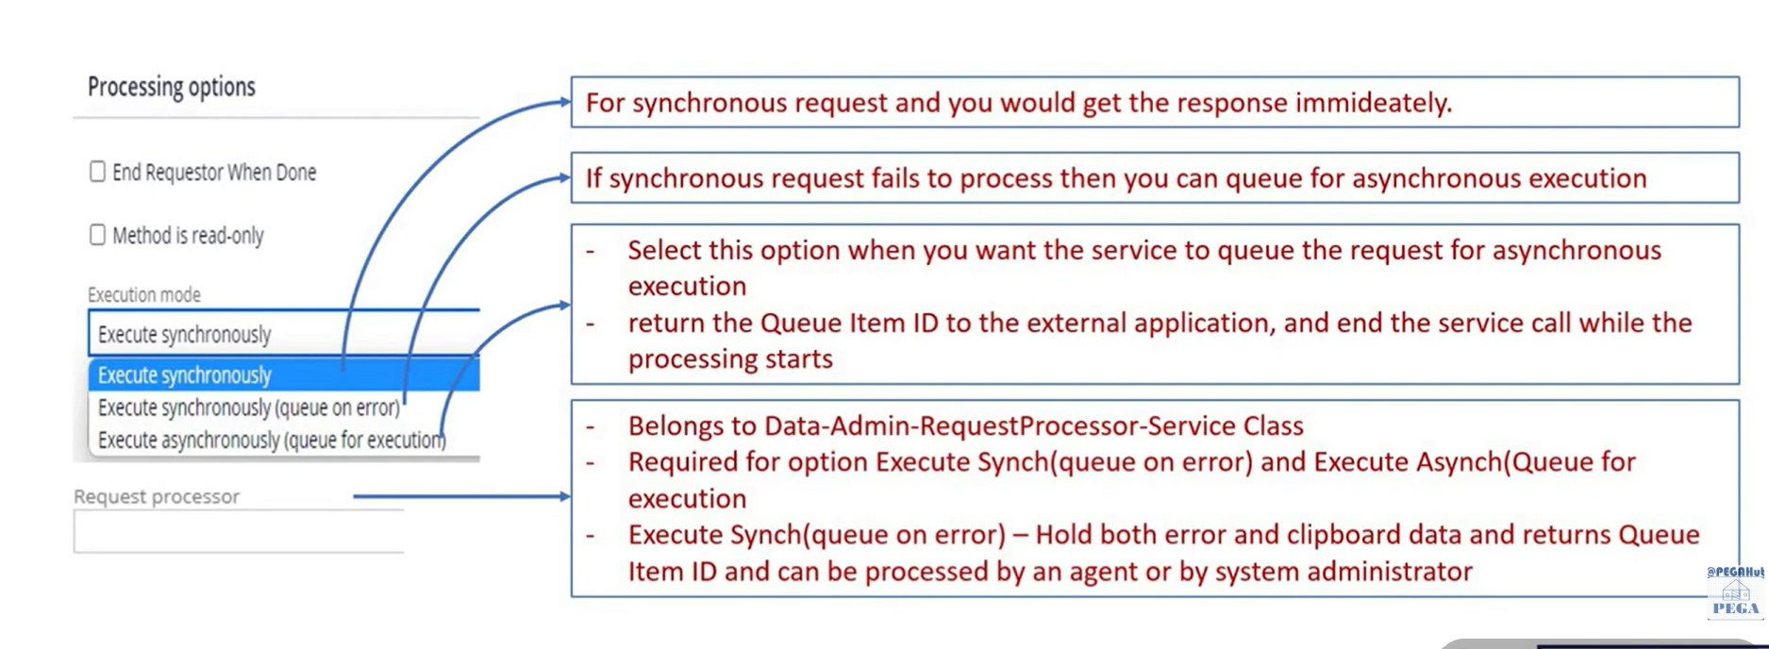

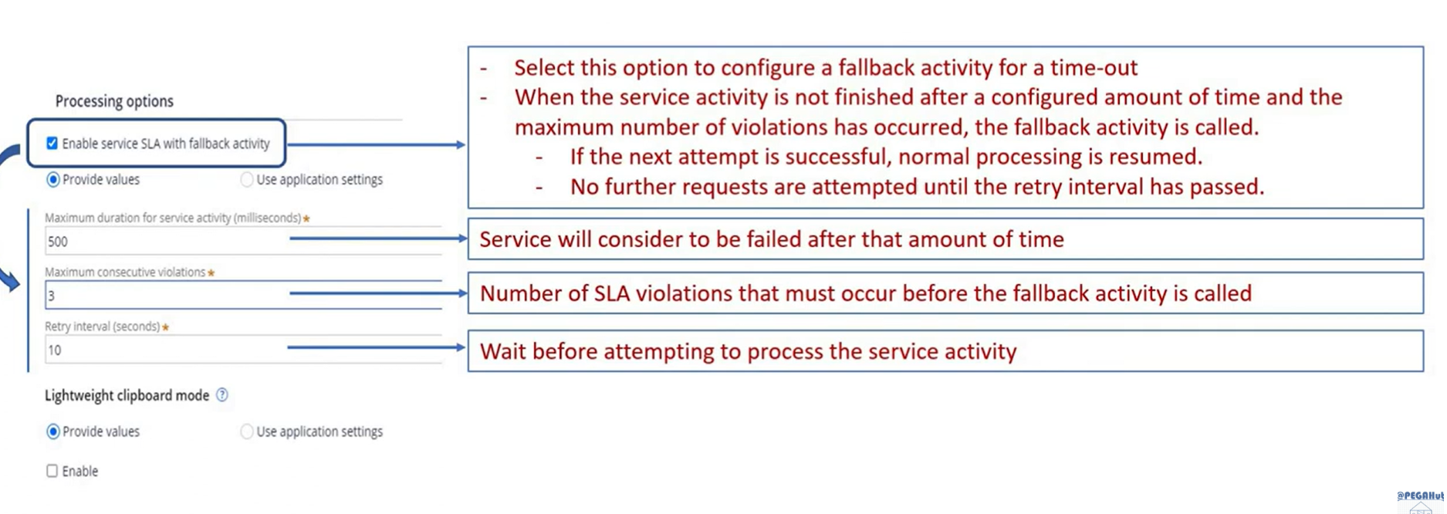
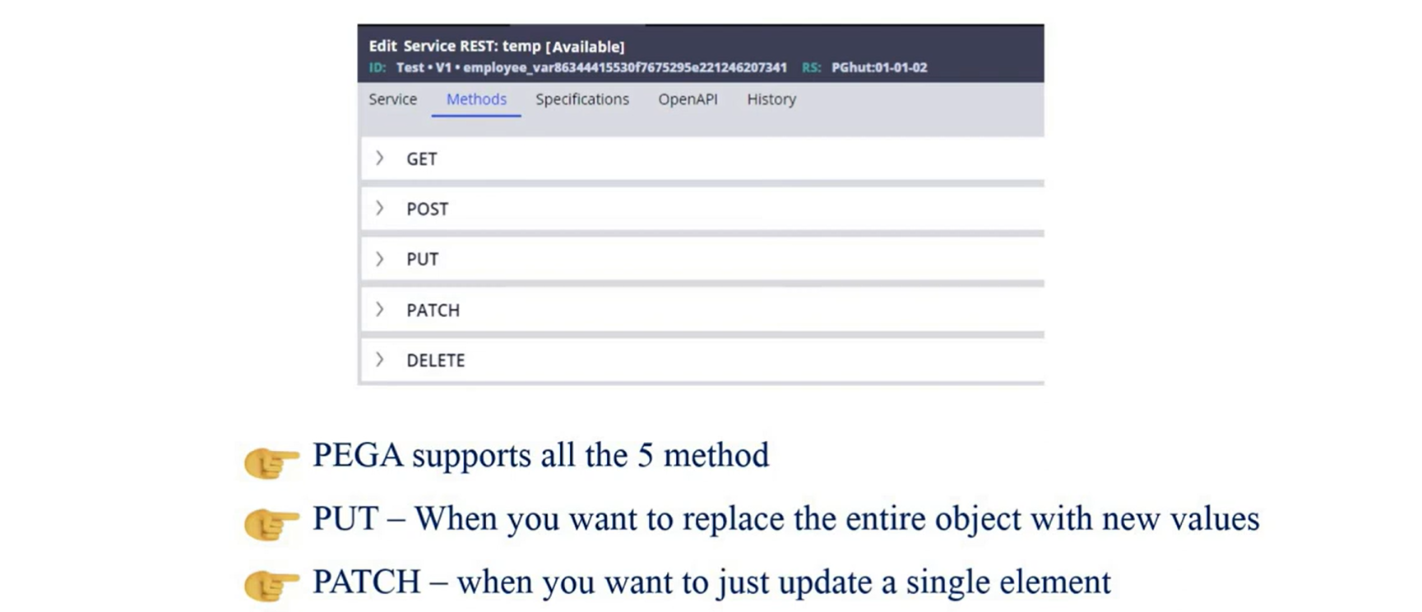
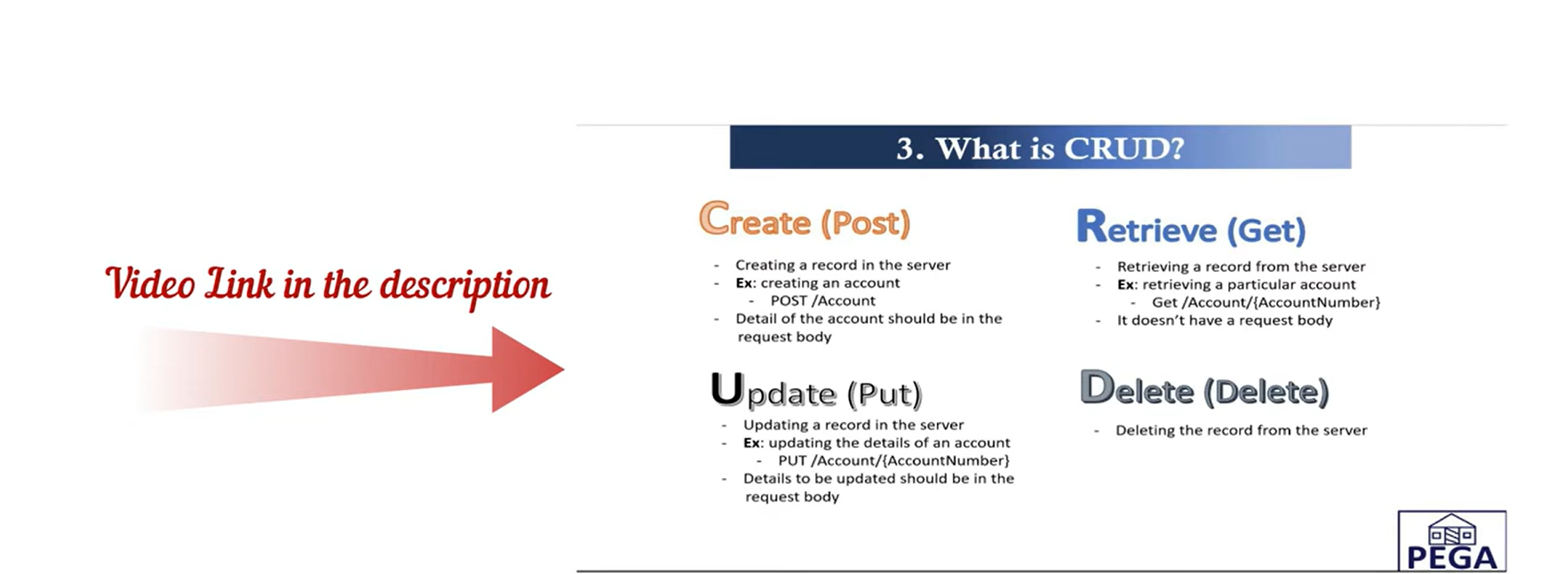
DATA TRANSFORM SER vs DESER
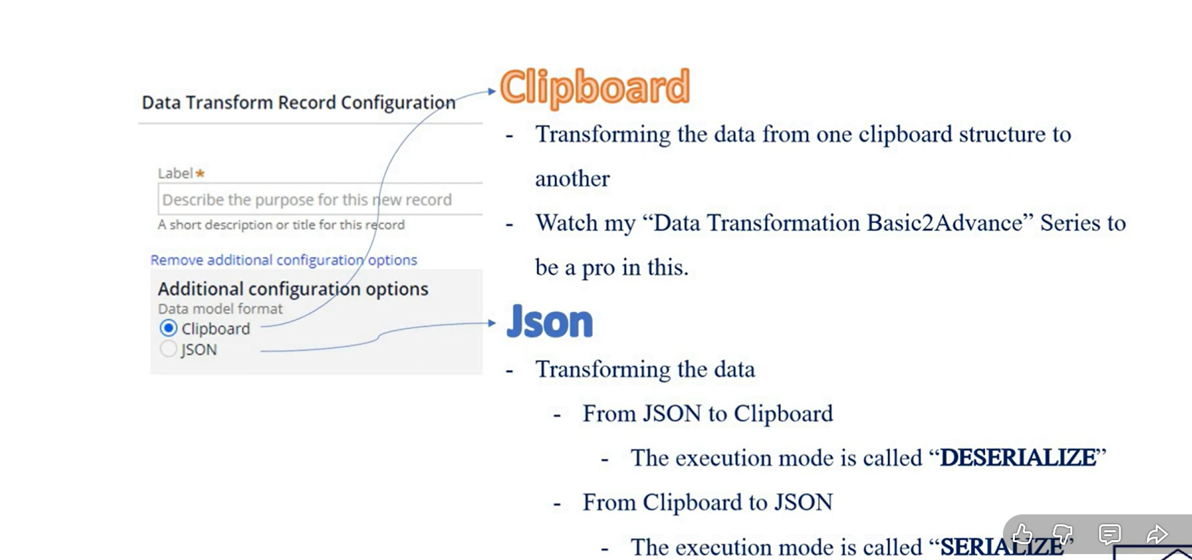
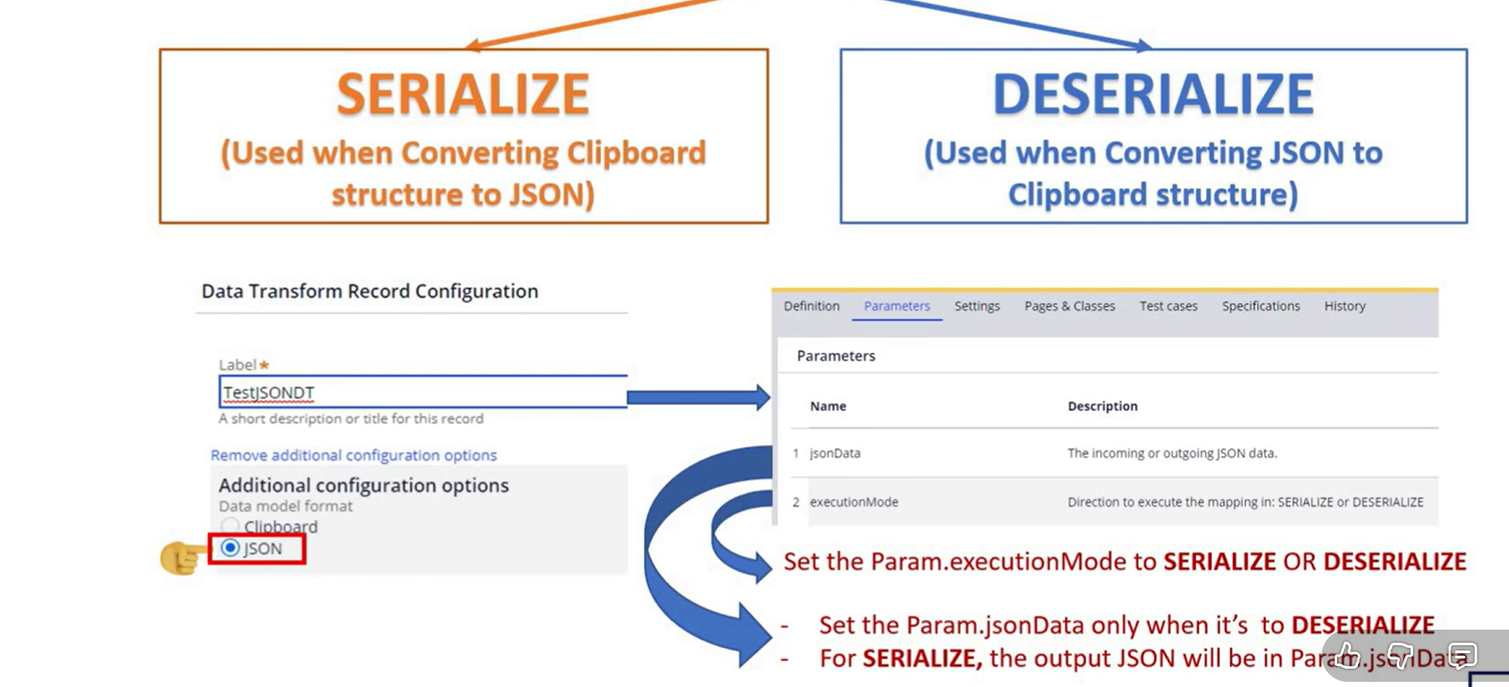

Queue Processor / asynchronous processing:
Suppose a case needs to perform a long-running operation asynchronously.
You may need to capture the required information and pass it to a Queue Processor. Complex data can be serialized into a message payload and later reconstructed when the queue item is processed.
Interviewer: "Where would you use serialization and deserialization in Pega?"
"I would use serialization when I need to convert a complex Pega object, page, or data structure into a format that can be transmitted or stored, such as JSON, XML, or a byte representation. Deserialization is used to reconstruct the object from that representation. Common scenarios include integrations, asynchronous messaging or queue processing, caching, and storing complex dynamic data. However, I would avoid serialization when individual fields need to be queried, indexed, or reported from the database."

